**Department of Electronic & Telecommunication Engineering**

**University of Moratuwa**

**EN 2073 – Analog and Digital Communications**



Assignment - 01

Name : Rathnayaka R.G.H.V.

Index No : 180529E

**April 2, 2021**

This Report is submitted as a partial fulfillment of the requirement

for the module EN2073 – Analog and Digital Communications

1. Plot of y(t)

The plot of the given 𝑦(𝑡) = 𝐴 ∗ 𝐶𝑜𝑠(2 ∗ 𝜋 ∗ 𝑓 ∗ 𝑡) signal for 10ms where f = 400 Hz and A = 1 (a.u) is given below in *Figure (01).*

Figure (01) – Plot of y(t)

1. Nyquist sampling frequency (fnq)

The Nyquist sampling frequency for the for the given signal can be easily calculated as it is twice of the frequency of the signal.

Therefore, Nyquist sampling frequency (fnq) = 2 x frequency = 2 x 400 Hz = **800 Hz**

1. Ideal sampling the signal at Nyquist sampling rate (fnq)

The plot after ideal sampling at the Nyquist sampling rate is given below in *Figure (02).*

Figure (2) – Sampled signal at fnq

1. Sampling the signal at 2 times Nyquist sampling rate & at one-half of Nyquist sampling rate

The plots for the sampled signals at Nyquist sampling rate, twice of the Nyquist sampling rate and one-half of the Nyquist sampling rate are depicted from the below *Figure (03).*

Figure (03) – Sampled signal at Fnq, 2Fnq  & Fnq/2

* The above three plots show the ideally sampled signal at the Nyquist rate, sampled signal at twice of Nyquist rate and the sampled at one-half of Nyquist rate.
* The ideally sampled signal, which was sampled at the Nyquist rate, shows only the minimum and maximum points. So, we can predict the original signal to some extent.
* The sampled signal at twice of the Nyquist rate shows mid values in addition to the minimum and the Maximum points represented by the ideally sampled signal. Although the mid values are zero, it will be advantageous in discovering the original signal from the sampled signal. This gives a high accuracy than the earlier situation.
* It is unable to discover the original signal from the sampled signal at one-half of the Nyquist rate as there are only the maximum points in the sampled signal.
* So, as a whole,
  + if the **frequency of the sampled signal (f_s) = Nyquist sampling rate (f_nq),** it is able to recover the original signal.
  + if the **frequency of the sampled signal (f_s) > Nyquist sampling rate (f_nq),** it is very easy to recover the original signal with a high accuracy.
  + if the **frequency of the sampled signal (f_s) < Nyquist sampling rate (f_nq),** it is unable to recover the original signal.

1. The minimum number of bits (nb) required per a sample and number of minimum quantization levels (L) required

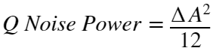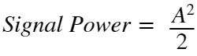since 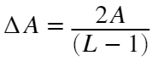, 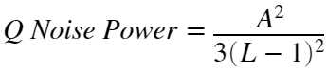

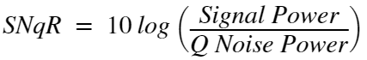

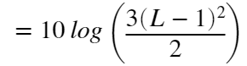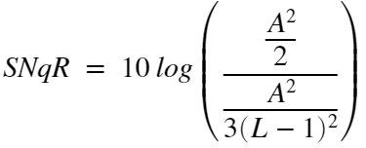

To exist a ratio greater than 25dB,

> 25dB

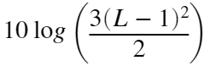

> 25

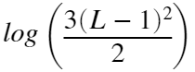

> 2.5

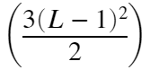

> 102.5

> 14.5196



L is an integer.

Therefore, **the minimum number of quantization levels (L) required is 16.**

As ,



**The minimum number of bits (nb) required is 4**.

1. MATLAB function to take a sampled value, number of quantization levels (L) and range (maximum amplitude) and to output the quantized value

The MATLAB function which can output the quantized value by taking sample value, number of quantization levels and amplitude range is given below under *Figure (04).*

Figure (04) – Function for calculating quantized value.

1. Sampling the signal at 8 times Nyquist sampling frequency (8fnq) and quantization

The plots for the sampled signal at 8 times of Nyquist sampling frequency and the Quantized signal with 16 quantization levels is given below in the *Figure (05).*

Figure (05) – Sampled signal at 8 times of Nyquist sampling frequency and Quantized signal with 16 quantization levels

1. Quantizing the above sampled signal for L*2 and L/2 quantization levels

The plots for the quantized signal with 16 quantization levels, 32 quantization levels and 8 quantization levels are given below under *Figure (06),* *Figure (07)* and *Figure (08).*

Figure (06) - quantized signal with 16 quantization levels

Figure (07) - quantized signal with 32 quantization levels

Figure (08) - quantized signal with 8 quantization levels

**Observations :**

* With the decrease of the number of quantization levels accuracy of the signal get reduced. Number of bits needed in representation get reduces. As a result, complexity may reduce.
* With the increase of the number of quantization levels accuracy of the signal get increased. Number of bits needed in representation get increases. As a result, complexity may increase.
* It is better to select the optimum number of quantization levels which provide a high accuracy and a good SNqR.